**Pediatric EHR System**

Pranay Savva

**Table of Contents**

Introduction 2

Business Description-Background 2

Business Case 2

Business Problems 2

Benefits of the Database Design and Application 2

Database Design 2

List of Entities-Attributes 2

Business Rules Definition & Assumptions 2

Relationship Definitions 2

Entity-Relationship Diagram 2

Database Implementation 2

SQL Code 2

Table Creation 2

SQL Query 2

Query Results-Added Value 2

Conclusion 2

Appendix 2

References 2

# **Introduction**

## **Business Description-Background**

Established in 1992, UHealth Pediatric Mobile Clinic is a mobile multidisciplinary clinic offering quality care services provided "on the go" similar to a traditional pediatrician’s office; specifically targeting local uninsured children of the community. The mobile clinic has medical service offerings from school-sports physicals to immunizations/vaccinations to mental healthcare/psychological evaluations; the clinic bus is always posted near Miami-Dade public schools, community centers, and even places of worship-religious institutions to cater to communities regardless of their insurance coverage, financial resources, or medical history.

Additional services and practices include:

* Primary medical care
* Urgent care
* Management of chronic conditions
* Screenings
* Well-visits
* Follow-up visits after treatment
* Social Work
* Health Education

More importantly, these services offered by the clinic are free as the mobile care team is comprised of specialists from University of Miami or referrals to UHealth Hackson Children’s Care system.

The director of the mobile clinic is known as Lisa Gwynn and the mobile clinic is described to be 38 feet in stature, offering two large slide-outs doubling the interior room size, with a separate door and room for nursing and other treatments. The clinic has all rooms equipped with standard examination equipment and medical devices as well as medical translation services for local families originating from Latin America and the Caribbean.

## **Business Case**

Due to the upheaval caused by COVID19, the medical field faced severe challenges and setbacks ranging. The pandemics impact has led to a decrease in person visits and a significant decline, in pediatric vaccination rates. This situation has underscored the importance of implementing diverse care delivery approaches to ensure that patients are reached effectively.

In the changing world of medical clinics, for children the use of database management systems and Structured Query Language (SQL) has become extremely important in enhancing the organization, retrieval and analysis of patient information. Like healthcare organizations, in general pediatric practices are increasingly relying on database systems to handle Electronic Health Records (EHRs) and enable more effective data driven decision making. However, implementing these systems comes with its set of difficulties.

These challenges arise in the realms of data security, interoperability between systems, and the need for tailored database structures that accommodate the specific nuances of pediatric healthcare. Also, primary business issues stem from lacking efficient systems to manage critical aspects of our healthcare operations, including patient information, appointments, visit time, medical records, and billing. As observed with the physical vaccination cards, manual practices and processes are still utilized to create medical records-documentations; pediatric clinics still experience both time-consuming and greater chances for human error leading to inefficiencies, clerical errors, and challenges in delivering timely, extended visit times with providers and accurate healthcare services. As we delve into the intricacies of how pediatric practices leverage database management and SQL, we will also highlight obstacles they confront; better understanding the required balance between technological innovation and the demands of pediatric patient care.

## **Business Problems**

Given the UHealth Pediatric Mobile Clinic is specifically tailored to “on the go” and “easily accessible-affordable" medical services, it is imperative these common inefficiencies in patient information management, medical record keeping, and extended visit times with providers have to be addressed in order to help better serve the local communities. These common issues hinder clinics from achieving efficiency and effectiveness given manual administrative processes introduce the potential for cascading human errors. Additionally, it is crucial for clinics to establish infrastructure that can handle amounts of data and is specifically designed for managing services in underserved communities. These challenges highlight the need for an efficient data management solution to be implemented.

## **Benefits of the Database Design and Application**

The introduction of this relational database design will significantly bolster the UHealth Pediatric Mobile Clinic's ability to adeptly organize and manage extensive data volumes across diverse local communities, covering patient information, appointments, medical records, and billing. In the realm of Electronic Health Records (EHRs), the relational database will empower the clinic to efficiently arrange and retrieve patient information, thereby reducing the risk of errors and enhancing the overall operational efficiency. In the context of appointments, the database will enable the clinic to utilize an application for automating appointment scheduling, thereby minimizing conflicts and vastly improving the patient appointment experience.

Furthermore, centralizing medical-billing records within the database and establishing a comprehensive backlog of medical history and treatment plans will empower providers to deliver superior patient care and make more informed decisions regarding diagnoses. The advantages offered extend beyond mere data organization, encompassing crucial considerations such as security, regulatory compliance, data validation, and performance optimization, all of which present significant potential upsides for the healthcare organization.

**Database Design**

## **List of Entities-Attributes**

To address the highlighted business case challenges, the implementation of a relational database using MySQL offers a suitable solution to improve the UHealth Pediatric Mobile Clinic’s operations. This database will consist of multiple tables, each representing different hypothetical entities-attributes as follows:

* **Patients (Entity):**
  + Columns (Attributes): PatientID (Primary Key), FirstName, LastName, DateOfBirth, Gender, GuardianFirstName, GuardianLastName, GuardianContactNumber, GuardianEmail, Address, GuardianRelationship
* **Appointments (Entity):**
  + Columns (Attrbutes): AppointmentID (Primary Key), PatientID (Foreign Key), DoctorID (Foreign Key), AppointmentDate, AppointmentTime, Status, etc.
* **Provider (Entity):**
  + Columns (Attributes): DoctorID (Primary Key), FirstName, LastName, Specialty, ContactEmail, ContactPhone, etc.
* **MedicalRecords (Entity):**
  + Columns (Attributes): RecordID (Primary Key), PatientID (Foreign Key), DoctorID (Foreign Key), AppointmentID (Foreign Key), Diagnosis, Prescription, TestResults
* **Billing (Entity):**
  + Columns (Attributes): BillID (Primary Key), PatientID (Foreign Key), AppointmentID (Foreign Key), Amount, BillingDate, PaymentStatus, etc.

## **Business Rules Definition & Assumptions**

Some general business rules regarding this business case primarily focused on the following:

* Use primary and foreign keys to establish relationships between tables
* Implement indexes for efficient querying
* Ensure the security and privacy of patient information in compliance with healthcare regulations
* Implement data validation rules to maintain data integrity

Additionally, some assumptions regarding this business case were:

* Patient Identification – unique identifier for each patient is created within the database
* Appointment Scheduling – appointments per time slot are enforced; reduced wait times
* Staff Roles-Permissions – determine access to patient records; user account creation
* EHRs – transition from paper-based records; accuracy of treatment plans-diagnoses

## **Relationship Definitions**

Each entity within the relational database has a specifically defined relationship with other associated entities as well as factoring the different attributes; listed are the defined relationships:

* Patients can have multiple appointments and medical records (One-to-Many relationship)
* Appointments are scheduled with specific doctors-providers (Many-to-One relationship)
* Medical records are associated with patients, providers, and appointments (Many-to-Many relationship)
* Billing records are related to patients and appointments (Many-to-One relationship)
* Providers and other entities including medical records, billing records, and patients are characterized as a (One-to-Many relationship)

## **Entity-Relationship Diagram**

# **Database Implementation**

## **SQL Code**

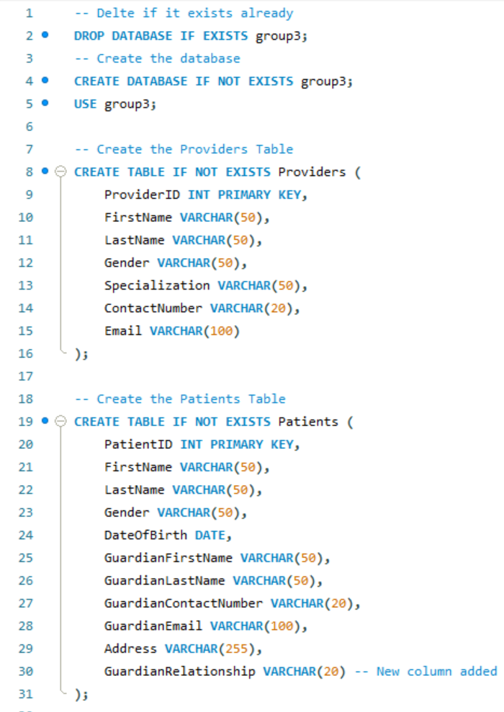

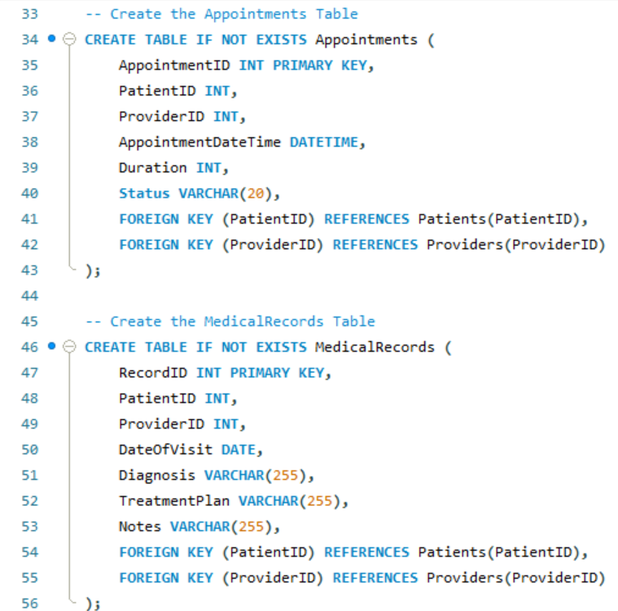

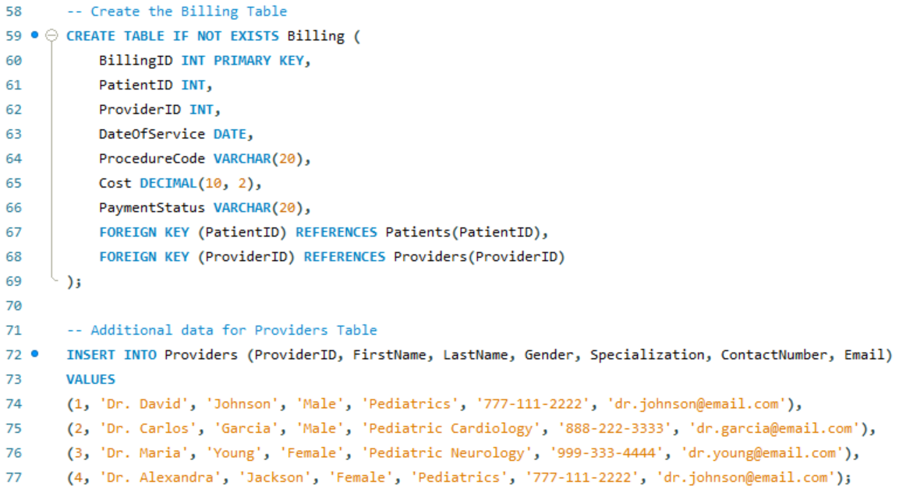

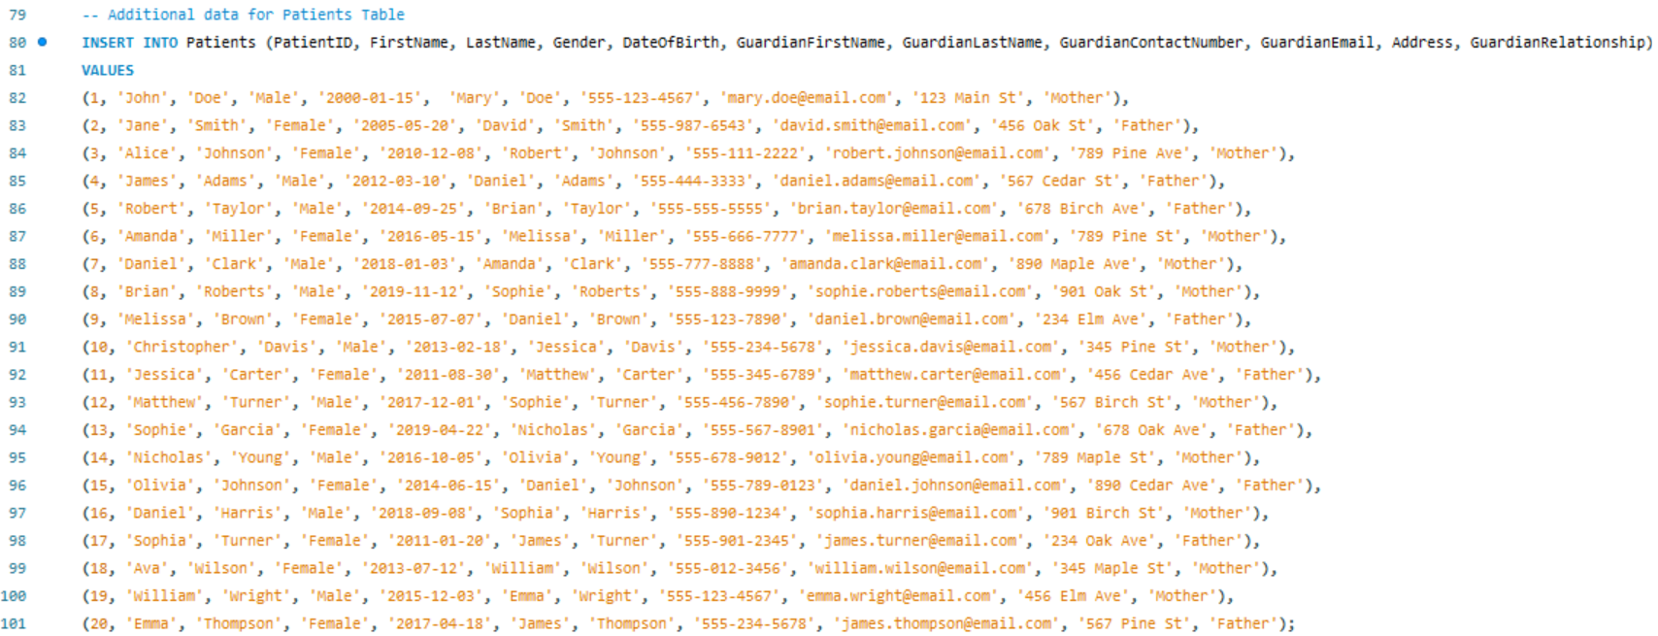

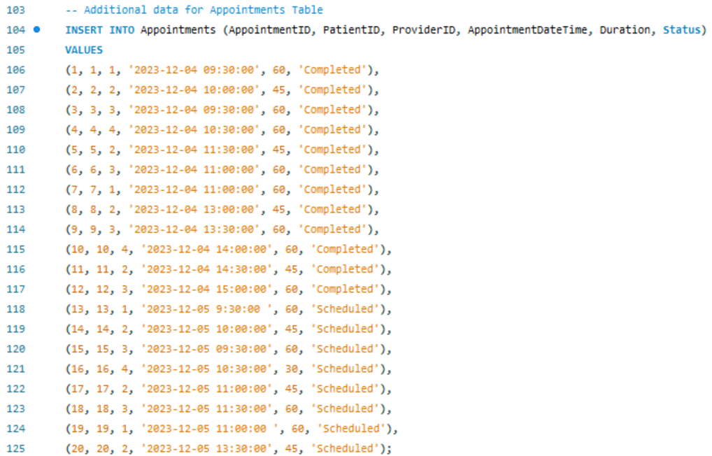

### **Table Creation**

**Patients Table:**

* + PatientID (Primary Key)
  + FirstName
  + LastName
  + Gender
  + DateOfBirth
  + GuardianFirstName
  + GuardianLastName
  + GuardianContactNumber
  + GuardianEmail
  + ContactNumber
  + Address
  + GuardianRelationship
* **Appointments Table:**
  + AppointmentID (Primary Key)
  + PatientID (Foreign Key referencing Patients table)
  + ProviderID (Foreign Key referencing Providers table)
  + AppointmentDateTime
  + Duration
  + Status (e.g., Scheduled, Completed, Canceled)
* **MedicalRecords Table:**
  + RecordID (Primary Key)
  + PatientID (Foreign Key referencing Patients table)
  + ProviderID (Foreign Key referencing Providers table)
  + DateOfVisit
  + Diagnosis
  + TreatmentPlan
  + Notes
* **Billing Table:**
  + BillingID (Primary Key)
  + PatientID (Foreign Key referencing Patients table)
  + ProviderID (Foreign Key referencing Providers table)
  + DateOfService
  + ProcedureCode
  + Cost
  + PaymentStatus
* **Providers Table:**
  + ProviderID (Primary Key)
  + FirstName
  + LastName
  + Specialization
  + ContactNumber
  + Email

## **SQL Query**

The listed objectives and the listed queries with respect to the clinic primarily stemmed from replicating hypothetical examples of use cases the healthcare providers might encounter with respect to utilizing the relational database via MySQL. The (10) listed objectives were the following:

1. Q1: Retrieve all medical records for a specific patient

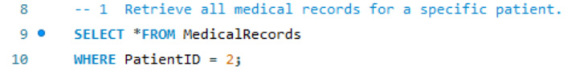

1. Q2: Find upcoming appointments for a particular doctor

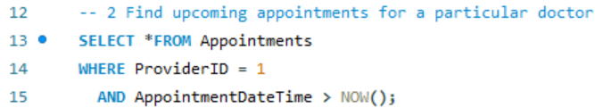

1. Q3: Generate a billing summary for a specific patient

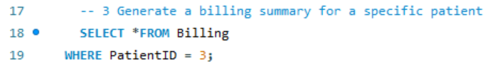

1. Q4: Identify patients with a specific diagnosis

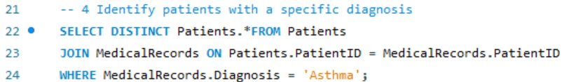

1. Q5: Patients that are newborns that have scheduled routine check-ups

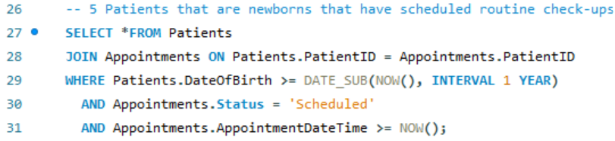

1. Q6: Patients between 10 and 15 that are either prescribed an inhaler or antibiotics

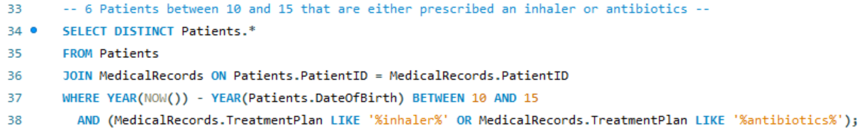

1. Q7: Patients that live on Pine St and or Elm Ave that are female

\

1. Q8: Patients with the names Sophie, Matthew, and James

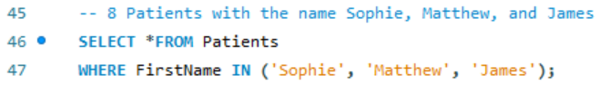

1. Q9: Patients that have the same last name and are born in 2010

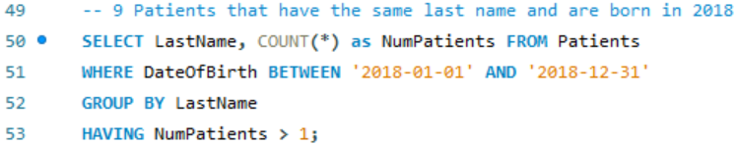

1. Q10: Patients with appointments scheduled between 9:30 – 11:00 with a completed status

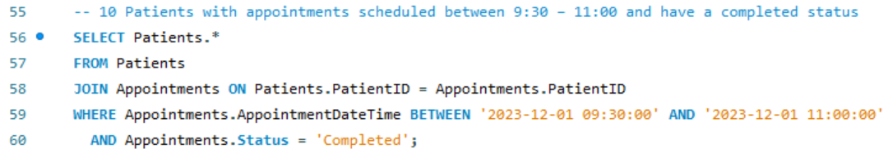

### **Query Results-Added Value**

These query results per the associated objective cases focused on specific instances of retrieving pertinent data points to facilitate better strategic-operational efficiency. The following results included:

1. Q1 Result-Added Value: PatientID 2 has their EHR displayed with the personal data. This shows how the clinic healthcare providers are able to streamline and gather latest treatment plans- diagnosis over a patient's medical history-previous visits

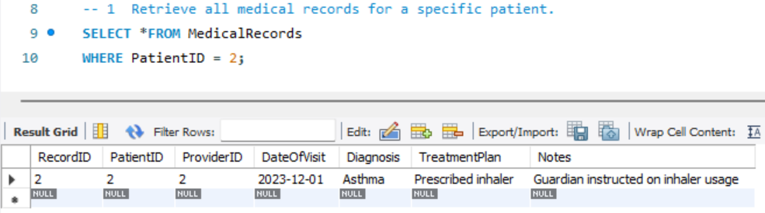

1. Q2 Result-Added Value: ProviderID 1 has their patient-appointment-duration schedule displayed with confirmation status. This shows how the clinic healthcare providers are being booked and which providers may be overbooked or needs to be reallocated-prioritized; personnel-resource allocation.

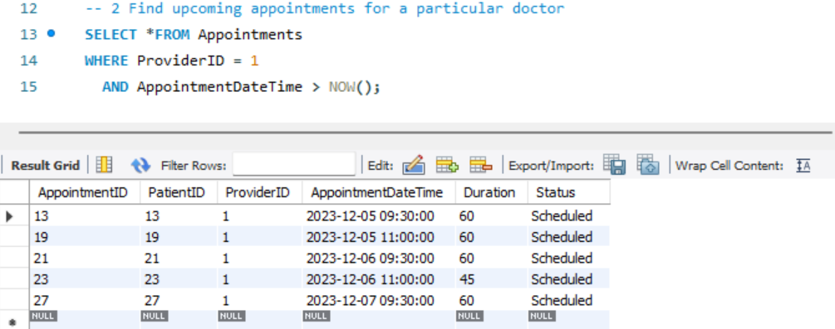

1. Q3 Result-Added Value: PatientID 3 has their billing balance displayed for the associated cost amount of $250 that has been paid per the last documented date of service with ProviderID3. This shows how the clinic is able to track financial transactions for associated treatment plans as well as the payment status for patients.

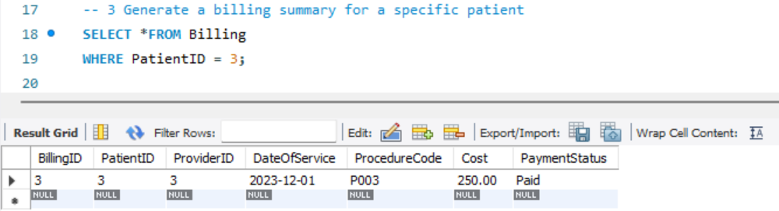

1. Q4 Result-Added Value: PatientIDs 2, 11, 20, & 24 all have been diagnosed with a case of Asthma and have the respective guardian information listed. This shows how a clinic is able to tailor a search and target a specific patient profile for a specific condition to either tailor treatment plans or identify specific commonalities.

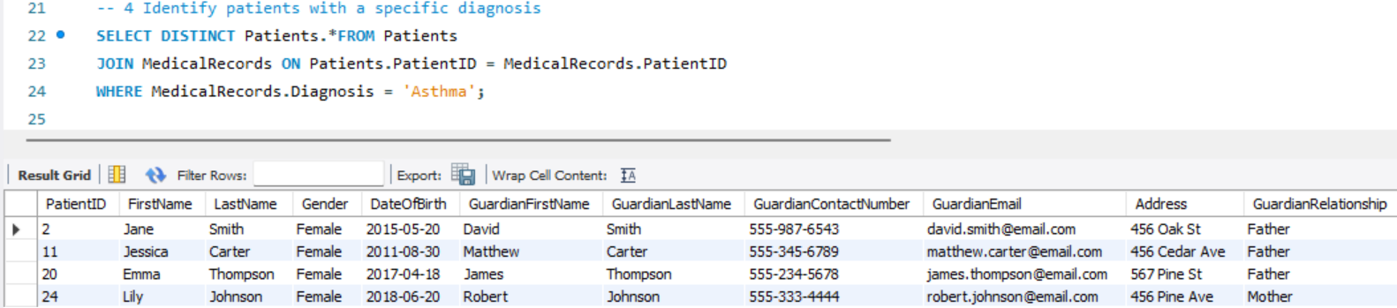

1. Q5 Result-Added Value: PatientIDs 21, 22, & 28 all are respective newborns that have scheduled their appointments for routine checkups. This allows the clinic to gage how many "new additions" to the specified community have been checked up; negative or positive trend in a community concerning health-safety protocols.

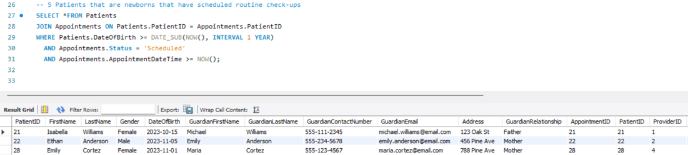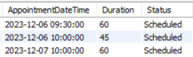

1. Q6 Result-Added Value: PatientIDs 4 & 11 are between the specified age range and require one of the two treatment plans specific to an inhaler or antibiotics. This allows the clinic to track specific sickness or ailments that are targeting a specific age range amongst patients.

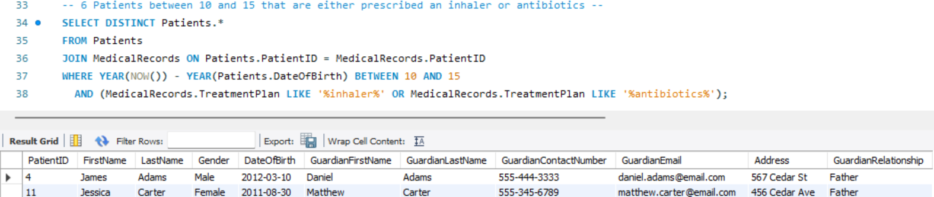

1. Q7 Result-Added Value: PatientIDs 6, 9, & 20 are all females living within the two specified street locations. This allows the clinic to check geographic concentration of a specific gender to draw any similarities in the patient's location to conditions or sicknesses.

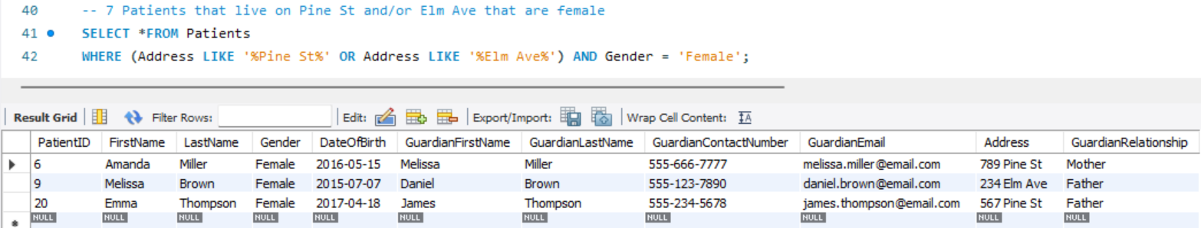

1. Q8 Result-Added Value: PatientIDs 4, 12, & 13 all have the specified name profiles. This allows the clinic to track or sort any patients with duplicative files-records with the same names.

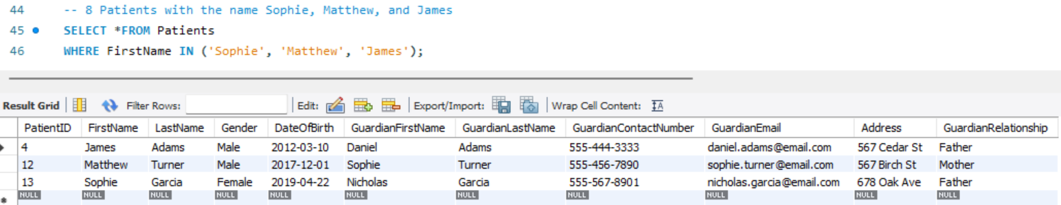

1. Q9 Result-Added Value: Patients that have the last name Clark and are born in the specified year 2018 for a total of two cases. This allows the clinic to check for any similarities (last names) amongst patient profiles within a specific year.

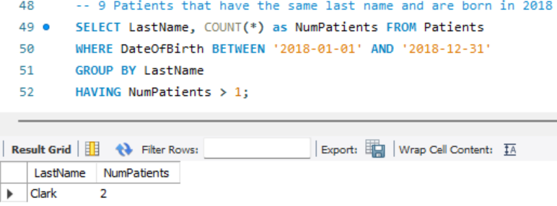

1. Q10 Result-Added Value: PatientIDs 1-7 all have had their appointments between the specified time range. This allows the clinic to effectively track and managed calendar schedule within a specific period (2hrs, morning) and to see how many patients have been seen.

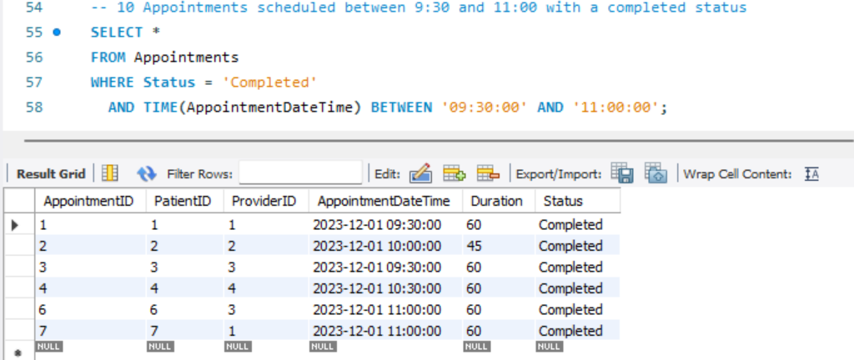

# **Conclusion**

In conclusion, the implementation of a well-designed relational database using MySQL, accompanied by a user-friendly application, stands as a critical solution to the current challenges faced by the UHealth Pediatric Mobile Clinic. The comprehensive database design, encompassing entities such as Patients, Appointments, Providers, Medical Records, and Billing, addresses key issues in patient information management, medical record keeping, and extended visit times with providers.

The outlined business rules, assumptions, and relationships between entities further reinforce the robustness of the proposed solution. By leveraging primary and foreign keys, implementing efficient indexing, ensuring data security and privacy, and incorporating data validation rules, the relational database promises to enhance the organization, retrieval, and analysis of extensive data volumes across diverse local communities.

The benefits derived from this database design and application are substantial. From streamlining Electronic Health Records (EHRs) and automating appointment scheduling to centralizing medical-billing records, the UHealth Pediatric Mobile Clinic stands to gain operational efficiency, reduced errors, and improved patient care. The added value demonstrated through specific query results underscores the practical advantages of the proposed solution, showcasing its potential to revolutionize the clinic's strategic and operational efficiency.

In essence, this database implementation is not merely a technological upgrade but a transformative tool that empowers healthcare providers to navigate the complexities of pediatric care with agility and precision. As the UHealth Pediatric Mobile Clinic continues its mission of providing easily accessible and affordable medical services to local uninsured children, the relational database emerges as a cornerstone for sustaining and advancing the clinic's commitment to efficient, accurate, and patient-centered care in underserved communities. Through this technical capability, the clinic is poised to overcome manual administrative inefficiencies, ensuring a sound infrastructure to support the increasing volume of patient data while maintaining the highest standards of healthcare delivery.

# Appendix

Group 3 shared the work evenly and had no issues with the arranged agreement as far as the associated rubric for dividing-sharing the workload for this project.

|  |  |  |  |
| --- | --- | --- | --- |
| **Name** | **PID** | **Contribution (%)** | **Work Descriptions** |
| David Correa | 3789073 | 25 | SQL Code/Query Development |
| Lloyd Howell | 6375878 | 25 | PPT, Report Development |
| Pranay Karthik Savva | 6410855 | 25 | SQL Code/Query Development |
| Joulie Sylvain | 1502614 | 25 | PPT, Report Development |

# References

Leibowitz, A., Livaditis, L., Daftary, G., Pelton-Cairns, L., Regis, C., & Taveras, E. (2021, December). *Using mobile clinics to deliver care to difficult-to-reach populations: A covid-19 practice we should keep*. Preventive medicine reports. <https://www.ncbi.nlm.nih.gov/pmc/articles/PMC8428151/>

Savage, E., Risings, J., & Gibson, C. (2018, November 1). *Identifying Electronic Health Record Usability And Safety Challenges In Pediatric Settings*. HealthAffairs. <https://www.healthaffairs.org/doi/10.1377/hlthaff.2018.0699>

UMiamiHealth. (n.d.). *UHealth Pediatric Mobile Clinic*. University of Miami Health System. <https://umiamihealth.org/en/treatments-and-services/pediatrics/uhealth-community-pediatrics-program/uhealth-pediatric-mobile-clinic>